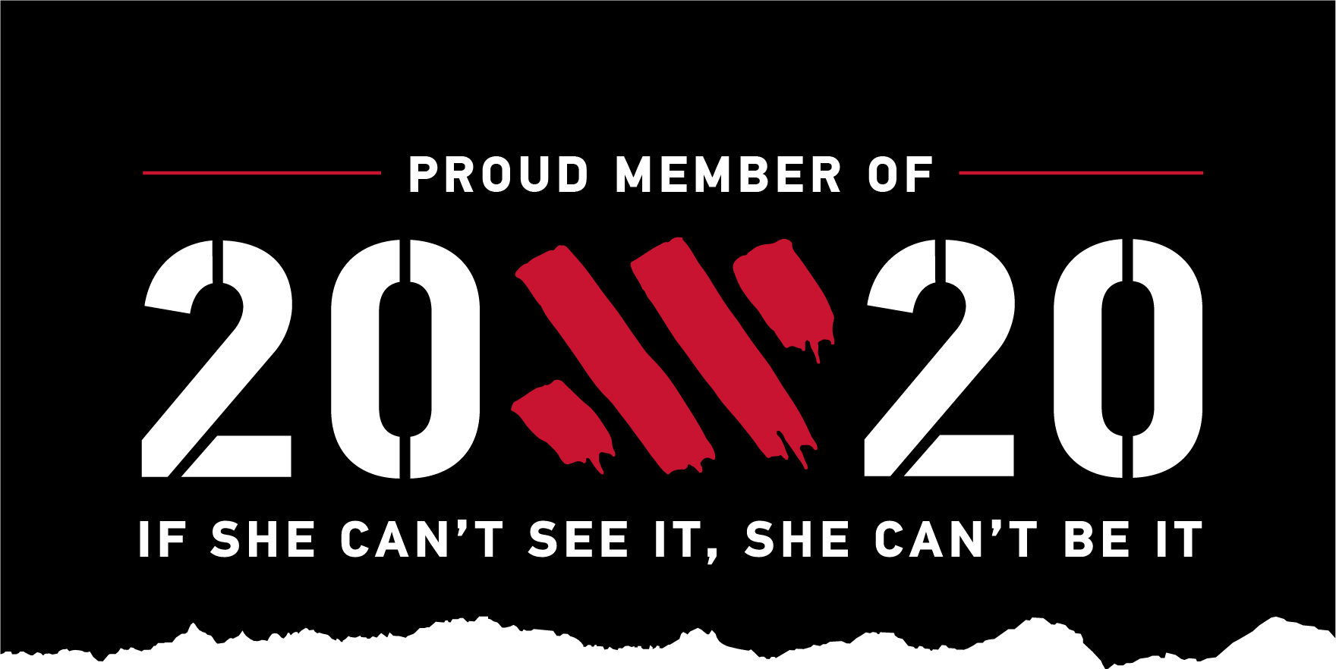
WOMEN'S DEVELOPMENT OFFICER REPORT 2020
MEMBERSHIP Current female members – 54 which is equivalent to a 1:5 ratio of female to male (20%) An encouraging number of new members joining in the last few months are female.
ACHIEVEMENTS
*TIME TRIALS
Karen Hull - 4th Overall Woman in Ernie Magwood Super League Six Sept/Oct 2020
Bronze medal in Ulster 10mile TT Championships, Female Masters Category
6th Senior Woman in Thomas White Memorial TT October 2020

*ROAD RACING
Julie Rea - 1st in Woman's Masters Hill Climb Ulster Championships Sept 2020

*CYCLOCROSS
Judith Russell – 1st Masters Woman in National Cyclocross Championships Jan 2020
1st Masters Woman in Ulster Cyclocross Championships Jan 2020
3rd place Women's Seniors (no masters category) Ulster Cyclocross Series 2019
6th place Brian Kinning GP Women’s Race
1st Master (5th Overall) Round 1 Ulster Cyclocross Series Square Wheels
Julie Rea - 3rd place in Masters Woman in Ulster Cyclocross Championships Jan 2020

OTHER ACHIEVEMENTS
Julie Rea - - 1st Woman in Lakeland Gravel Grinder Oct 2020
Transatlantic Way Cycle Aug/Sept 2020. Moville to Kinsale, 1500km, 15,027m of ascent, 12 days cycling, self supported

Karen Jack --
LEJOG August 2020. Land’s End to John O'Groats, 9 days cycling with approx 100miles each day taking in many iconic climbs along the way
Titanic Torr 200 Audax Cycle July 2020

LEISURE CYCLING
RAPHA WOMEN'S 100 RIDE – on 6th Sept 2020 new member Helen McParland arranged a Ladies Run to Island Magee. 16 club members participated in this day out which takes place every year to encourage women on every continent to ride 100km in one day to inspire each other to achieve a collective goal
WOW – Women on Wheels Programme. Phoenix CC was signed up and ready to repeat the success of the 2019 pilot programme. Last year we had 24 registered, 16 completing the course and 8 new members in 2019. 4 of these women have continued their membership and join in regular club cycles. The retention rate would probably been higher if Covid 19 had not intervened. Unfortunately the WOW Programme 2020 was cancelled due to the pandemic.
Ladies Bun Runs – cancelled due to Covid19 Ladies Sports Nutrition Talk (follow on from last year’s nutrition talk) – postponed due to Covid19
UPCOMING EVENTS None currently scheduled due to Covid19. See Club Development Plan for future plans.
20×20 Charter
Phoenix CC is now proudly signed up to the 20×20 Charter. This is a national movement in sport across all of Ireland. Involved clubs have pledged to support women and girls to become more involved in sport. Rebecca Fitzgerald is the Clubs Female Champion and James Gordon is the Clubs Male Champion for this project.
Gillian Steele
Women’s Development Officer 2020

